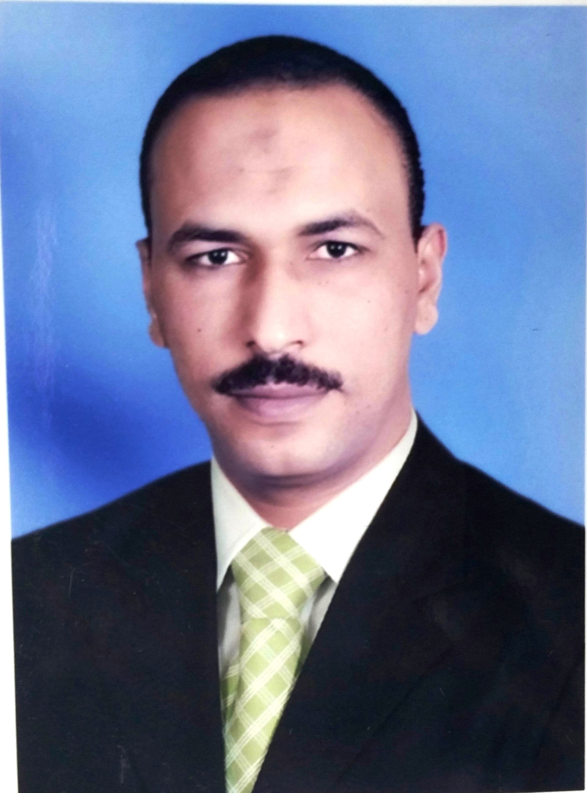 Curriculum Vitae (C.V.)

Omran Khodary Qenawy Ahmed
Personal Information | - Date of birth: 8/4/1974  - Age: 41  - Sex: male.  - Residence: EL Besary ,Khadra EL shirifa street,. Assuit. Egypt  - Phone number: (01117298484).  - Email: omranshow@yahoo.com  - Marital status: single.  - Nationality: Egyptian.  - Place of Birth: Aswan, edfu, Egypt.  - Military service: finished  - Current position: Lecturer of Radiodiagnosis Department-Faculty of Medicine-Assuit university.
Summary of qualifications | - MBB.ch postgraduate in 1999 very good degree .  - M.Sc. in Radiology : Assiut University Hospital 2006 very good  - House officer: Assiut University Hospital (1/3/2000-28/2/2001).  - Resident (Radiology ): Assiut University (1/3/2002-31/8/2006).  - Resident in US unite assuit university hospital with different varieties (abdominal ,thyroid ,scrotal ,obstetric & Gyn. , transvaginal US and US guided biopsy )  - Resident in CT unite with different varieties and X-ray (conventional and with CM studies )  - Resident in MRI unite with different varieties  - Have the following experiences  - US with all different verities as Abdominal , pelvic, Obstetric, Thyroid, Scrotal , Breast ,Transvaginal, Musculoskeletal US and transcranial US  - X-rays –especially orthopedic cases ,GIT ,Chest and Trauma unite cases  - CT with all different and special maneuvers  - MRI  - Interventional. Us guided biopsy and aspiration cytology,  - Cardio-pulmonary resuscitation & emergency course)  - TEACHING ACTIVITY:
Education | School : Graduated from EL Kharaza primary , Edfu sugar factory preparatory and secondary school  - University: Faculty of Medicine Assuit University.  - Master degree in Radiology Assuit university.
Languages | - Mother language: Arabic  - Second language: English (Excellent).  - Third language: French (fair).

